Suction Regulators

Recommendations for Cleaning, Disinfection and Reprocessing:

Boehringer 3800 &3900 Series
Suction Regulators

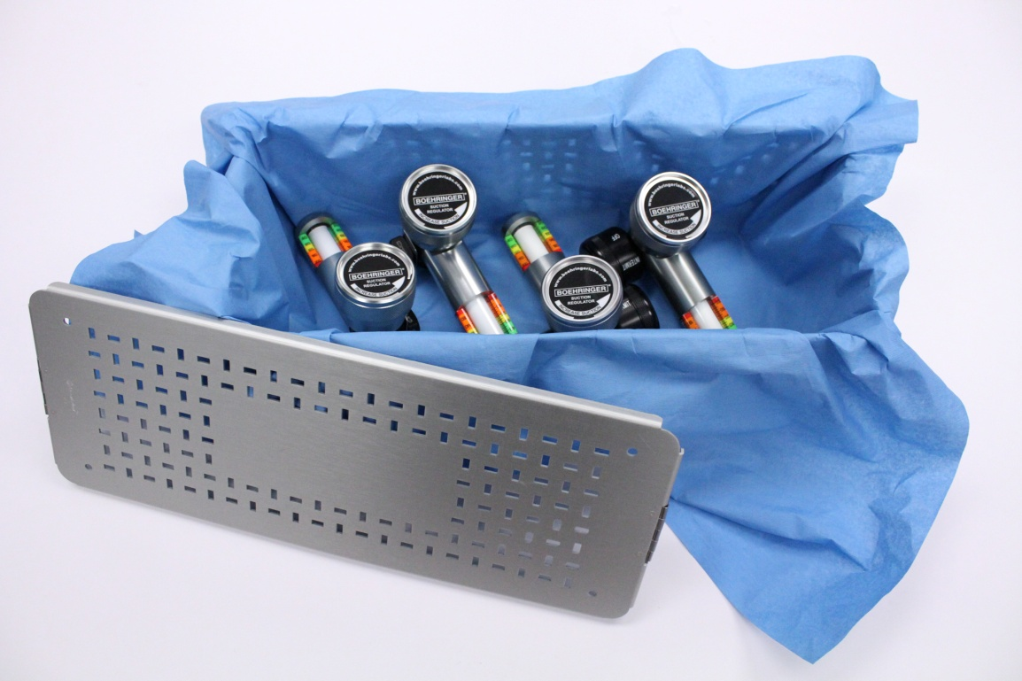

Boehringer Laboratories, LLC
300 Thoms Drive
Phoenixville, PA 19460
(800) 642-4945

Quick Reference

The following recommendations represent the best current contemporary clinical practices for handling medical suction regulators and are considered the minimum acceptable standards for handling this class of instruments.

Event | Processing Method | Reference
1. Point of Care Use | Point of Care External Surface Disinfection | Page 7
2. Subsequent to Fluid Intrusion | Clean & Sterilize | Pages 8-9
3. Prior to Service  (Repair) | Clean & Sterilize | Pages 8-9

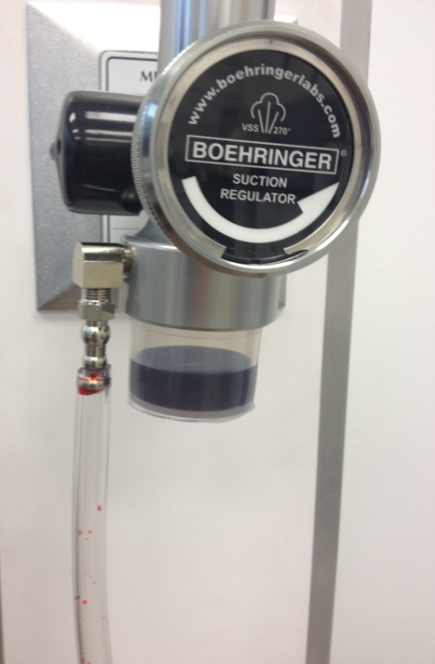
Rationale:
- Room Turnover - - The outside of a suction regulator is a high-touch, non-critical surface and should be treated similarly to the balance of these surfaces in the patient care environment.

- Subsequent to Fluid Intrusion - - Suction collection systems employ a variety of mechanical mechanisms to discourage fluid from entering the suction regulator. Failure of any of these means or human error can lead to patient secretions being pulled into the regulator. Risk of patient cross contamination is increased subsequent to fluid intrusion. Fluid intrusion can be readily identified by any debris or fluid in the gravity trap bottle(1) or any fluid in the line leading from the collection canister to the regulator(2), or observed clinical failure of any of these systems. Clinicians should be advised as to how to identify this occurrence.
1
2

- Prior to Service - - The leading cause of regulator failure is inadvertent fluid intrusion. Most hospital service areas lack the appropriate workspace and personal protective equipment to safely handle contaminated instruments. It is recommended these instruments are cleaned and sterilized prior to being sent for repair.

Unit Identification

ONLY BOEHRINGER SUCTION REGULATORS WITH THE “VSS-270” LOGO MAY BE PROCESSED USING THIS MANUAL. For all other products, please refer to the specific instructions for use for that product which is available on our website….www.boehringerlabs.com

VSS270 Logo

3800 & 3900 Series  Regulators | 9100 Series  Trap Bottles | 3800 & 3900 Series Regulators with Integral Trap bottle installed.
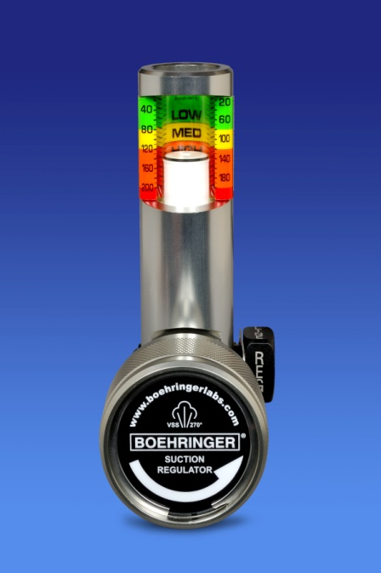 | 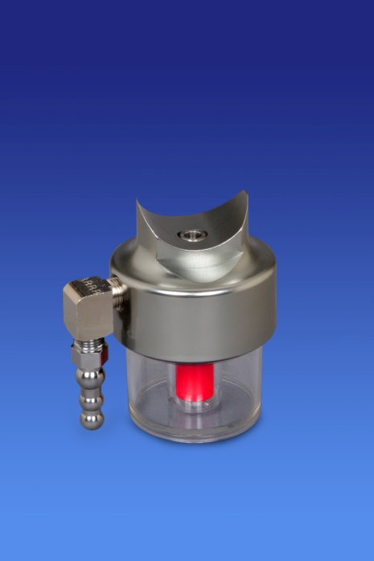 | 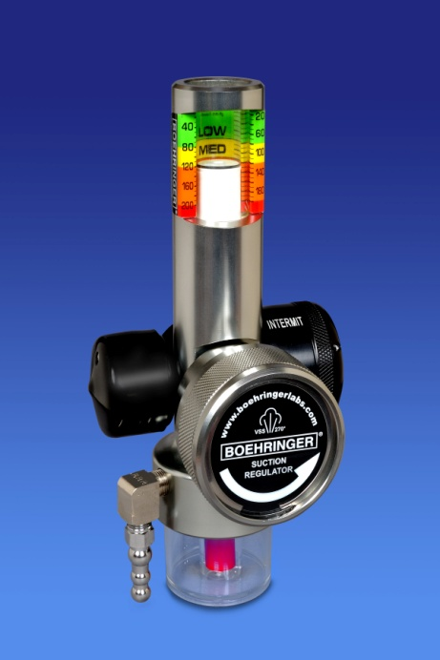

Introduction

These recommendations are for processing Boehringer 3800 & 3900 series suction regulators as well as 9100 series trap bottles. The sterilization guidelines in this manual have been validated and are in accordance with:

- ANSI/AAMI ST81:2004/(R) 2010 – Sterilization of medical devices-Information to be provided by the manufacturer for the processing of resterilizable medical devices.
- AAMI TIR 12:2010 – Designing, testing, and labeling reusable medical devices for reprocessing in health care facilities. A guide for device manufacturers 1st ed.
- AAMI ST77:2006/(R) 2010 – Containment devices for reusable medical device sterilization.
- ISO 14937:2009 – Sterilization of health care products – General requirements for characterization of a sterilizing agent and the development, validation and routine control of a sterilization product.

models

This document contains recommended instructions for the safe care, handling and processing of the 3800 & 3900 series of Boehringer suction regulators, produced after December 31, 2010. This manual also applies to all Model 9100 Fluid Trap Bottles sold after March 2012. To identify the lot number of your instrument, please refer to the complete product instructions for use. This processing guide is an addendum to, and not a replacement for the complete instructions for use for your suction regulator. Please refer to www.boehringerlabs.com or call 1-800-642-4945 to obtain the complete instructions for use for your regulator.
Cleaning

The cleaning protocols described herein are intended to be used on suction regulators that have been grossly contaminated (presence of debris or fluid intrusion). Devices that show no signs of debris or fluid intrusion may have sufficiently low bio-burden such that they may only require processing through external cleaning/disinfection. It is the responsibility of the hospital to determine whether or not decontamination is required.
Processing

The instructions contained herein describe methods by which Boehringer suction regulators can be processed to ensure patient and staff safety. Processing is defined as the act of rendering the device safe for patient use or staff handling by either external disinfection of the device or sterilization. It is the responsibility of the hospital to ensure that any devices subjected to these guidelines have been appropriately processed.
Rerocessing

The term reprocessing used herein refers to the sterilization process which encompasses specific cleaning procedures if fluid intrusion occurs thereby requiring steam sterilization.

Terminology

CAUTION | Alerts user to actions or conditions that can cause damage to the device or may result in substandard performance of the device or system.
CLEANING | Removal of foreign material (soil, organic material) from an item
CONTAMINATED | State of having been actually or potentially in contact with microorganisms
IMPORTANT | Indicates an action that is emphasized to ensure proper operation of equipment
MANUAL CLEANING | Cleaning without the use of a washer or washer-disinfector
PROCESSING | Act of subjecting medical devices to the various routes used for point of care cleaning/ disinfection or sterile reprocessing
STERILIZATION | A validated process used to render a device free from all forms of viable microorganisms
WARNING | Alerts user to actions or conditions that could result in injury to user or patient

Safety Information

WARNING!

- Boehringer suction regulators are intended to be cared for per the instructions in this manual as well as the instructions for use specific to each model of suction control. Failure to follow the guidelines herein may result in unsatisfactory levels of disinfection or sterilization and may compromise regulator performance.
- Suction regulators are used in a clinical setting on a variety of patients. The mechanisms that allow the regulators to function may contain biological contamination even though there are no apparent signs of contamination. Always utilize appropriate PPE when handling suction controls that have been in clinical use.
- Failure to ensure the suction regulator is functioning properly after processing can increase patient risk. Ensure suction controls function properly before they are returned to service.

CAUTION!

- Hydrophobic filters, gravity shut offs, and gravity safety traps provide a barrier to gross biological contamination but do not prevent microbiological pathogens from entering the suction regulator. Be mindful that these measures alone do not ensure a pathogen free device will be returned to clinical service.
- Avoid solutions containing high chlorine content (>1%) as this may cause irreversible damage to the suction regulator components.
- Devices that are visibly contaminated must be thoroughly cleaned before processing to ensure the efficacy of the disinfection / sterilization process.
- Immediate use steam sterilization (IUSS) is not a recommended process for Boehringer Suction regulators.

LIMITS ON REPROCESSING

- All detergents used should have a neutral pH.
- Repeated manual washing and sterilization as described herein should have minimal effects on the fitness for use of Boehringer 3800 & 3900 Series suction regulators.

Considerations

  - The end user / individual / department responsible for processing these devices should comply with local laws and ordinances in countries where reprocessing requirements are more stringent than those detailed in this manual.
- The use of personal protective equipment is recommended whenever handling a potentially contaminated piece of medical equipment.
- It is the responsibility of the hospital to ensure personnel have proper qualifications and are trained to perform disinfection and sterile reprocessing procedures.
- Equipment used for reprocessing should be validated and routinely monitored to ensure proper performance.
- Any deviation outside of these processing protocols should be properly evaluated for efficacy and potential adverse consequences.
- It is the responsibility of the hospital to ensure that suction regulators have been appropriately processed.

Point of Care Cleaning / Disinfection

Point of use Care

- The exterior surface is to be cleaned of any gross visible debris/soil. Particular care should be paid to the adjustment knob and the mode selection knob as these are the two most commonly touched surfaces by caregivers.
- Wipe all exterior surfaces of the suction regulator with a surface disinfectant per manufacturer’s instructions. Suitable hard surface disinfectants are:

Ethyl Alcohol-based | 60%-90% Concentration
Chlorine Based | a 1:10–1:100 dilution of 5.25%–6.15% sodium hypochlorite (i.e., household bleach).  (mix or use manufacturer-prepared chlorine based solutions or manufacturer-prepared wipes)  Never use undiluted bleach on these instruments.
Iodophors | Mix per manufacturer’s directions for use as a hard surface disinfectant.
Phenols | Mix or use manufacturer prepared wipes per manufacturer’s directions for use as a hard surface disinfectant
Quaternary Ammonium Compounds | Mix or use manufacturer-prepared wipes per manufacturer’s directions for use as a hard surface disinfectant.
Mode Selection Knob
Adjustment Knob

Reprocessing Instructions

1. Transport

- Suction regulators should be sent for processing as soon as possible if gross contamination is evident.
- Soiled and potentially contaminated suction regulators should be removed from service and transported separate from non-contaminated devices, in a container that minimizes the potential to spread contamination. Suction regulators should be transported in an upright orientation.
2. cleaning

If there is evidence of gross contamination the following procedures must be followed:
  - Disassemble the unit (refer to the device’s user manual for detailed instruction on disassembling the suction regulator). The instructions are available on our website www.boehringerlabs.com. =
  - After the suction regulator is fully disassembled, all regulator components should soak for a minimum of 10 minutes in a solution of warm water and pH neutral detergent such as MetriZyme®. Refer to the detergent manufacturer’s instructions for concentration recommendation.
  - After soaking, thoroughly rinse components with warm tap water.
  - Regulator components should be placed in a fresh solution of warm tap water and pH neutral detergent such as MetriZyme® and scrubbed with a soft bristle brush to remove deposits. Refer to the detergent manufacturer’s instructions for concentration recommendation.
  - The components should then be removed from the solution and rinsed with warm tap water.
  - Components should be placed in an ultrasonic cleaner and completely submerged for a minimum of 10 minutes.
  - Rinse components thoroughly with warm tap water.
  - Inspect regulator components for visible soil. Repeat cleaning process again if visible soil is observed.
  - Ensure components are dry before reassembling the suction control. If using an automatic dryer, ensure the temperature does not exceed 132°C (270°F).
3. STEAM STERILIZATION

- Ensure all suction regulators are properly assembled and the control knobs are turned to the REG or CONT. mode. Refer to each model’s instructions for use for guidance with proper assembly.
- Ensure the adjustment knob is turned counterclockwise until it stops to keep the internal passageways as open as possible.
- Suction regulators can be packaged in a variety of ways for processing including a peel pouch, sterilization wrappers or instrument tray.
- The following are recommendations for sterilizing Boehringer Suction Controls

Cycle Type | Minimum Sterilization Exposure Time (min) | Minimum Sterilization Exposure Temperature | Minimum Dry Time*
Pre-vacuum | 4 | 132° C (270°F) | 10 Minutes

*Dry times will vary depending upon a number of factors including packaging materials, environmental conditions, steam quality, regulator mass and sterilizer specification (cool down time and performance). The processor should visually inspect the regulator for signs of moisture.

4. Verification of Performance

- After Boehringer suction controls are processed, it is imperative they be checked for basic function before returning to service. Please refer to each specific model’s instructions for use for proper methods to check regulator performance.
- At a minimum check the following functions:
  - The regulator can maintain a constant level of vacuum.
  - The gauge properly indicates the vacuum level.
  - The regulator functions in all operating modes (eg. continuous, intermittent and line).
  - The regulator flow rate is in compliance with the model’s specifications.
- If you have questions at any time, please feel free to contact Boehringer at 1-800-942-4945.

References
Kaye, Keith, et. al. (2010). Suction regulators: a potential vector for hospital-acquired pathogens. Infection Control and Hospital Epidemiology, 31(7), 772-774.
Maragakis, Lisa, et. al.(2004). An outbreak of multidrug-resistant acinetobacter baumannii associated with pulsatile lavage wound treatment. JAMA, 292(24), 3006-3011.
“Use of Filters on Medical Gas System Outlets and Vacuum System Inlets” User Experience Network™, ECRI [Health Devices Dec 1994;23(12):494-5] .
Healthcare Product Comparison System “Regulators, Suction”. Dated January 2001. ECRI Institute, Plymouth Meeting PA.
Guidelines for Design and Construction of Healthcare Facilities: Facility Guidelines Institute; 2010 Edition. § 2.1-8.4.4.2 Vacuum systems
Guidelines for Disinfection and Sterilization in Healthcare Facilities, 2008.William A. Rutala, Ph.D., M.P.H., David J. Weber, M.D., M.P.H., and the Healthcare Infection Control Practices Advisory Committee (HICPAC)
Neary, Michael, et. al “The Clinical Importance of Unrestricted Flow in Hospital Suction Systems” Clinical white paper published August 2008 by Boehringer Laboratories, LLC.
Hill, John, et. al ”The Efficacy of Backflushing Suction Regulators as a Method of Internal Disinfection” Presented at the 55th Annual International Respiratory Conference (AARC 2009).
Kaye, Keith, et. al ”An Evidence Based Approach to Determining Hospital Suction Canister Change Protocols” Presented at the 37th Annual Meeting of the Association for Professionals in Infection Control and Epidemiology (APIC 2010).
Karpowicz, John, et. a.”Your Hospital’s Cost of Disposable Suction Regulators” Clinical white paper published September 2010 by Boehringer Laboratories, LLC

Boehringer Laboratories, LLC
300 Thoms Drive
Phoenixville, PA 19460

For
Customer Service
Or
Technical Support

800-642-4945

www.boehringerlabs.com

© 2012 Boehringer Laboratories, LLC.
A free trial evaluation
of any of our suction regulators
can be arranged by calling
(800) 642-4945

Gross contamination of suction equipment is an extraordinary event. Normal precautions such as the appropriate use of collection canisters, gravity trap bottles, and hydrophobic filters reduce, but do not eliminate the probability of such events.

